Project 1

Part1: Concurrency HTTP 1.0 server handling GET and HEAD

* We choose JAVA for implementation. Please check Server.java, ClientHandler.java, and GetMime.java.

Part2: Bonus

* Benchmarking your server using httpf

An example of using httpf is displayed as follow,

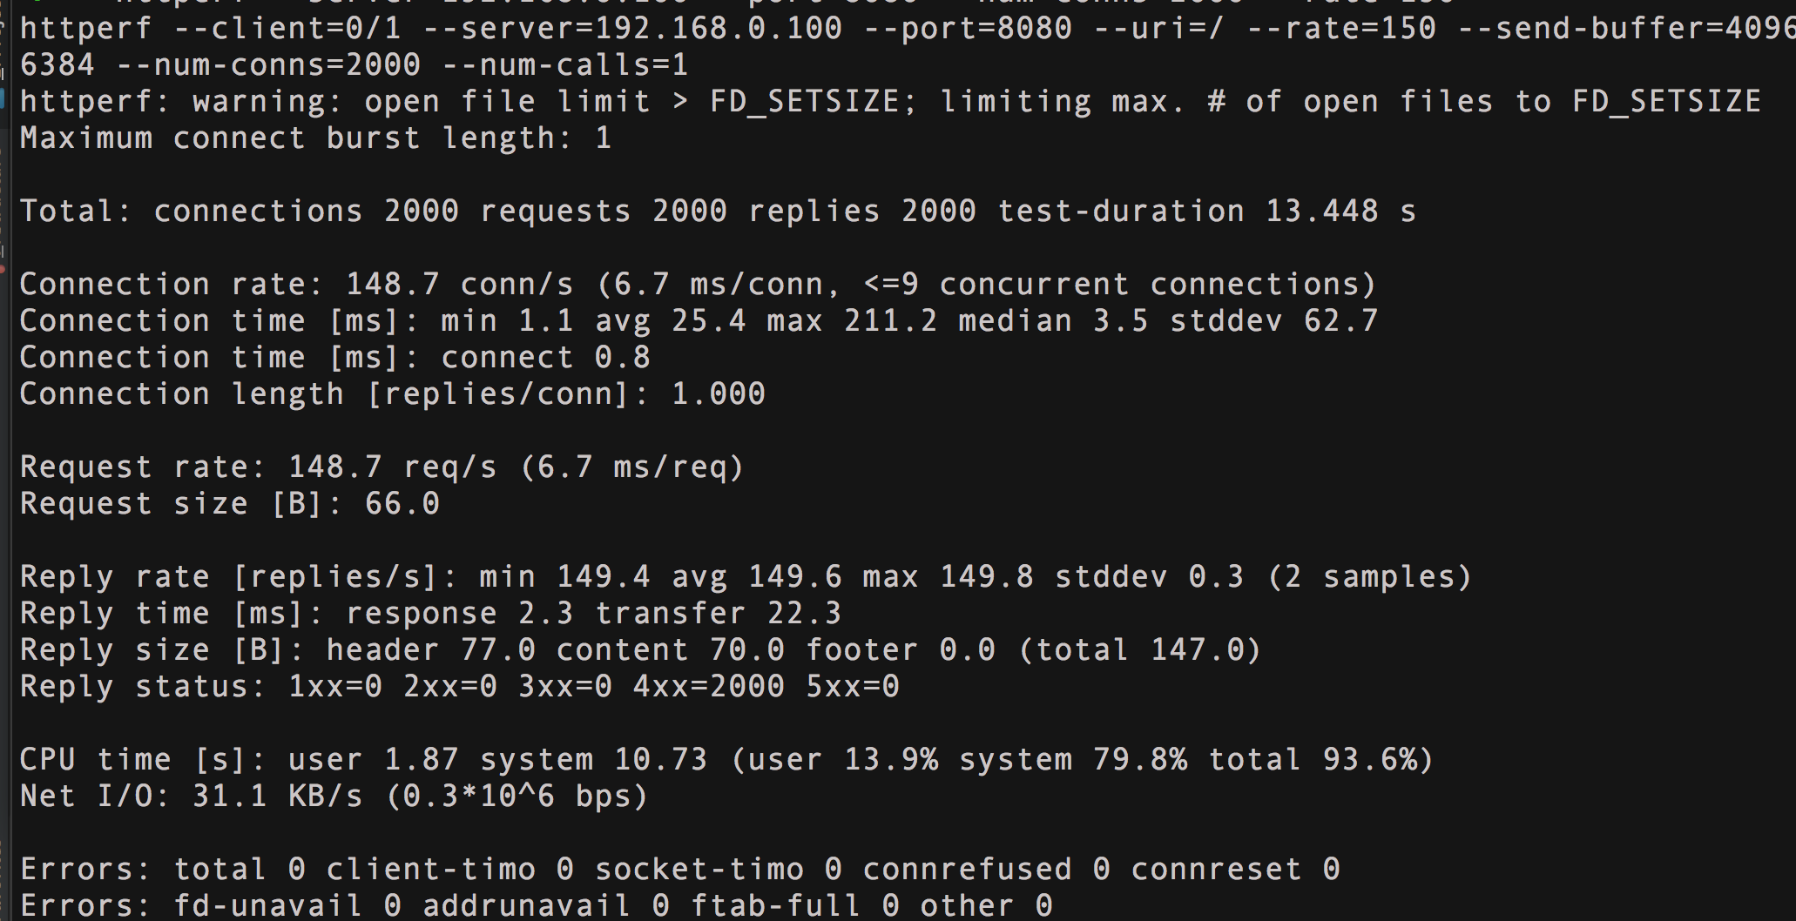

|  |  |  |
| --- | --- | --- |
| NumConn = 2000 |  |  |
| Request Rate[1/s] | Reply Rate[1/s] | Response Time (ms) |
| 100 | 99.9 | 2.8 |
| 150 | 149.6 | 2.3 |
| 200 | 199.2 | 2.5 |
| 300 | 299.0 | 3.4 |
| 400 | 398.2 | 1.3 |
| 500 | Seqmentation Fault | |

* Observation
* From the result displayed above, we may conclude the as the quest rate increased, the response time is nearly the same
* As we push the request rate up to 500 s-1 , there is segmentation fault occurred.